**Microservices: Account & Loan Services**

**Week 5**

**Folder Structure:**

Base folder : c:\<6393941>\microservices\

Account service: c:\<6393941>\microservices\account\

Loan Service: c:\<6393941>\microservice\loan\

**Account Service:**

1.Spring Initializer Setup:

Group:com.cognizant

Artifact:account

Dependencies:

Spring web

Spring Boot DevTools

Endpoint

Method:Get

[URL:http://localhost:8080/accounts/{12345}](URL:http://localhost:8080/accounts/%7b12345%7d)

**AccountController.java:**

@RestController

@RequestMapping("/accounts")

public class AccountController {

@GetMapping("/{number}")

public Account getAccount(@PathVariable String number) {

return new Account(number, "savings", 234343);

}

static class Account {

private String number;

private String type;

private double balance;

public Account(String number, String type, double balance) {

this.number = number;

this.type = type;

this.balance = balance;

}

public String getNumber() { return number; }

public String getType() { return type; }

public double getBalance() { return balance; }

}

}

**Pom.xml file for Account Microservice:**

<project xmlns="http://maven.apache.org/POM/4.0.0"

xmlns:xsi="http://www.w3.org/2001/XMLSchema-instance"

xsi:schemaLocation="http://maven.apache.org/POM/4.0.0

http://maven.apache.org/xsd/maven-4.0.0.xsd">

<modelVersion>4.0.0</modelVersion>

<groupId>com.cognizant</groupId>

<artifactId>account</artifactId>

<version>0.0.1-SNAPSHOT</version>

<name>account</name>

<description>Account Microservice</description>

<packaging>jar</packaging>

<parent>

<groupId>org.springframework.boot</groupId>

<artifactId>spring-boot-starter-parent</artifactId>

<version>3.2.0</version>

<relativePath/> <!-- lookup parent from repository -->

</parent>

<properties>

<java.version>17</java.version>

</properties>

<dependencies>

<!-- Web Dependency -->

<dependency>

<groupId>org.springframework.boot</groupId>

<artifactId>spring-boot-starter-web</artifactId>

</dependency>

<!-- DevTools -->

<dependency>

<groupId>org.springframework.boot</groupId>

<artifactId>spring-boot-devtools</artifactId>

<scope>runtime</scope>

</dependency>

<!-- Test -->

<dependency>

<groupId>org.springframework.boot</groupId>

<artifactId>spring-boot-starter-test</artifactId>

<scope>test</scope>

</dependency>

</dependencies>

<build>

<plugins>

<!-- Spring Boot Maven Plugin -->

<plugin>

<groupId>org.springframework.boot</groupId>

<artifactId>spring-boot-maven-plugin</artifactId>

<version>3.2.0</version>

</plugin>

</plugins>

</build>

</project>

**AccountApplication.java:**

package com.cognizant.account;

import org.springframework.boot.SpringApplication;

import org.springframework.boot.autoconfigure.SpringBootApplication;

@SpringBootApplication

public class AccountApplication {

public static void main(String[] args) {

SpringApplication.run(AccountApplication.class, args);

}

}

**Output:**

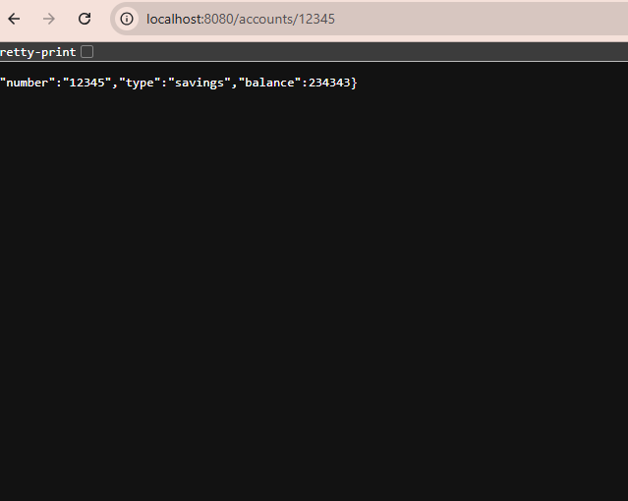

**Loan Service:**

Spring Initializer Setup**:**

Group:com.cognizant

Artifact:loan

Dependencies:

Spring Web

Spring Boot DevTools

URL: [URL:http://localhost:8081/accounts/{1234}](URL:http://localhost:8081/accounts/%7b1234%7d)

**LoanController.java:**

@RestController

@RequestMapping("/loans")

public class LoanController {

@GetMapping("/{number}")

public Loan getLoan(@PathVariable String number) {

return new Loan(number, "car", 400000, 3258, 18);

}

static class Loan {

private String number;

private String type;

private double loan;

private double emi;

private int tenure;

public Loan(String number, String type, double loan, double emi, int tenure) {

this.number = number;

this.type = type;

this.loan = loan;

this.emi = emi;

this.tenure = tenure;

}

public String getNumber() { return number; }

public String getType() { return type; }

public double getLoan() { return loan; }

public double getEmi() { return emi; }

public int getTenure() { return tenure; }

}

}

**Pom.xml file for Loan Service:**

<project xmlns="http://maven.apache.org/POM/4.0.0"

xmlns:xsi="http://www.w3.org/2001/XMLSchema-instance"

xsi:schemaLocation="http://maven.apache.org/POM/4.0.0

http://maven.apache.org/xsd/maven-4.0.0.xsd">

<modelVersion>4.0.0</modelVersion>

<groupId>com.cognizant</groupId>

<artifactId>loan</artifactId>

<version>0.0.1-SNAPSHOT</version>

<name>loan</name>

<description>Loan Microservice</description>

<packaging>jar</packaging>

<parent>

<groupId>org.springframework.boot</groupId>

<artifactId>spring-boot-starter-parent</artifactId>

<version>3.2.0</version>

<relativePath/> <!-- lookup parent from repository -->

</parent>

<properties>

<java.version>17</java.version>

</properties>

<dependencies>

<!-- Web Dependency -->

<dependency>

<groupId>org.springframework.boot</groupId>

<artifactId>spring-boot-starter-web</artifactId>

</dependency>

<!-- DevTools -->

<dependency>

<groupId>org.springframework.boot</groupId>

<artifactId>spring-boot-devtools</artifactId>

<scope>runtime</scope>

</dependency>

<!-- Test -->

<dependency>

<groupId>org.springframework.boot</groupId>

<artifactId>spring-boot-starter-test</artifactId>

<scope>test</scope>

</dependency>

</dependencies>

<build>

<plugins>

<!-- Spring Boot Maven Plugin -->

<plugin>

<groupId>org.springframework.boot</groupId>

<artifactId>spring-boot-maven-plugin</artifactId>

<version>3.2.0</version>

</plugin>

</plugins>

</build>

</project>

**LoanApplication.java:**

package com.cognizant.loan;

import org.springframework.boot.SpringApplication;

import org.springframework.boot.autoconfigure.SpringBootApplication;

@SpringBootApplication

public class LoanApplication {

public static void main(String[] args) {

SpringApplication.run(LoanApplication.class, args);

}

}  
  
**Output:**

